Your challenge, should you choose to accept it, is to find an awkward family photo like this one, and add your favorite celebrities faces. Please make sure that it is well blended. It should not look like you cut out faces and glued them on. You are better than that

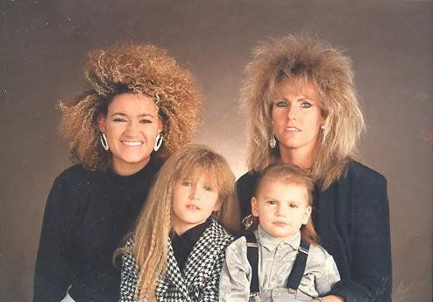

To the right are some great examples.

Option #2 is to create something as wonderful as this with some of the lighting photos you’ve taken.

