Name__________________________

Period________________

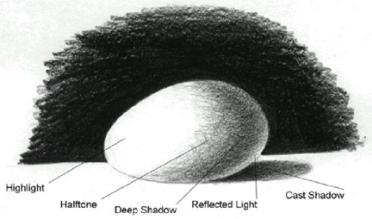

Correctly label the egg below

Complete the value scale:

Now do a blended value scale:

Draw, shade, and label (your drawing) the egg on your table.

